Software Requirements Specification

**Puzzles and Dragons Database**

* Author: William Gale
* Date: 2017-05-10
* Version: 1.02

# Revision History

|  |  |  |  |
| --- | --- | --- | --- |
| Date | Version | Revision Notes | Author |
| 2017-05-08 | 1.0 | Initial Scribing | William Gale |
| 2017-05-09 | 1.01 | Updated Document to be less Technical | William Gale |
| 2017-05-10 | 1.02 | Updated Product functions, Database requirements, added definitions, Added supporting game mechanic information. Changed style and color | William Gale |
|  |  |  |  |
|  |  |  |  |
|  |  |  |  |
|  |  |  |  |

# Table of Contents

1 Revision History 2

2 Table of Contents 3

3 Purpose 4

4 Scope 4

5 Product Overview 5

5.1 Product Perspective 5

5.2 Product Functions 5

5.3 User Characteristics 5

5.4 Limitations 5

6 Definitions 6

7 References 6

8 Specific Requirements 7

8.1 External Interfaces 7

8.2 Functions 7

8.3 Usability Requirements 7

8.4 Performance Requirements 7

8.5 Logical Database Requirements 8

8.6 Design Constraints 8

8.7 Software System Attributes 8

8.8 Standards compliance 8

8.9 Supporting Information 9

8.9.1 Game Mechanics 9

8.9.1.1 Player 9

8.9.1.2 Monsters 10

8.9.1.3 Team Building 13

9 Verification 14

10 Appendices 14

10.1 Assumptions and dependencies 14

10.2 Acronyms and Abbreviations 14

# Purpose

To build a database that will allow users to track progression of their monster collections. Allowing them to build simulated teams for future planning and comparing those teams to others for collaborative meta design.

# Scope

The PAD Database will keep track of base stats for all monsters available. It will allow multiple users to be able to create and store instances of monsters with specified Experience. Stats for Monster instances are calculated base on experience given to monsters. The database can also create teams from monster instances of 1 to 5 monsters to simulate team stats and multipliers. We are not concerned with in game currency values of the monsters.

# Product Overview

## Product Perspective

* The Database will be dependent on a program to handle its information properly.
* The Database will be updatable without lose of user information, allowing the database to reflect changes in current iterations of the Game Puzzles and Dragons.

## Product Functions

* Create Player – Creates a user within the database.
* Update Player – Update the stats of a user, Performed by that user only.
* View Player – View User Profile
* Create Monster – Creates a monster for the current user within the database.
* Update Monster – Update stats of Monsters owned by the currently log in user.
* View Monsters – Displays current users Monsters
* View Monster – Display monster, Current Stats and skills.
* Create Team – Assign 1 to 5 Instanced monsters to a team owned by currently log in user.
* Update Team – Updates team information for currently log in user’s team.
* View Team – Displays current user’s teams
* View other user Teams – View other user teams, but be unable to modify them.
* View other users – View other user’s stats, but be unable to modify them.
* View other user monsters – View monsters owned by other users, but be unable to modify them
* Delete Monster – Delete monster owned by currently logged in user, removes monster from teams if monster is currently in a team.
* Delete Team – Delete Team of currently logged in user.
* Delete Player – Close user Account of currently logged in user removing all information of said user.

## User Characteristics

The Target of the Database is for PAD Advocates that wish to fine tune their teams for more difficult dungeons, while also comparing them to other user’s teams.

## Limitations

* Updating Database to match latest version of PAD currently requires manually updating.
* Unable to parse information directly from Puzzles and Dragons Game, First Party Information Limited to instances.
* Information is Limited to current information available from PuzzleDragonx.com
* Requires application designed for utilizing the database

# Definitions

* Puzzle and Dragons – A game involving monster collection and team creation required to defeat more difficult Dungeons.
* Stats – The HP, ATK, and RCV of the monsters
* Attribute – The Element of the Monsters
* Type – The class of monster in Puzzles and dragons
* Active Skill – A usable skill that some monsters have
* Leader Skill – A passive skill that some monsters have
* Awoken Skills – A passive skill that a monster can have zero to nine of.
* Latent skills – Passive skills that can be assigned to monsters, up to a max of 6
* Dungeons – Levels within Puzzles and Dragons that offer unique challenges.
* Database - A structured set of data held in a computer, especially one that is accessible in various ways.
* Monster Assist – A monster assigned to another monster to offer a second active skill and slight stat boost.
* Rank – a player grading system that determines the amount of stamina, friends, features the Player can have.

# References

* Third party Puzzles and Dragons resource:
  + <http://puzzledragonx.com/>
* Gungho Official PAD Websites
  + <http://www.gunghoonline.com/games/puzzle-dragons/>
  + <http://puzzleanddragons.us/>

# Specific Requirements

## External Interfaces

* Accessible through an RDBMS for base information updating.
* Accessible through queries within an application for user access.

## Functions

* Storing all monster base stats
  + Parse information from PuzzledragonsX.com
* Creating Player Information – Player ID, Player Name, Player Attribute, and Rank

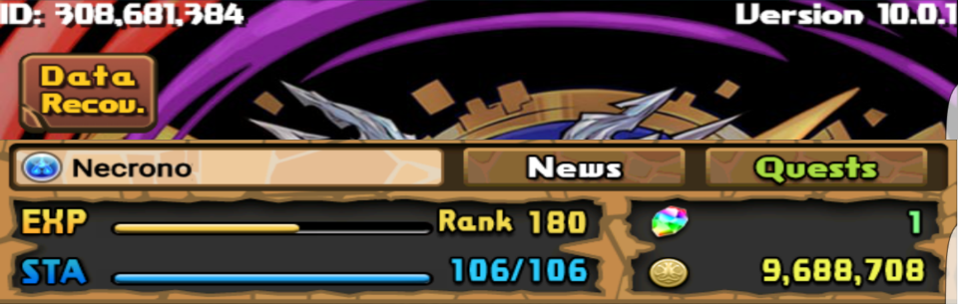

* Creating Monster Instances
  + Minimum information need for an instance shall be Player ID and Monster ID.
* Updating Monster Instances
  + Updating Current Experience, Plus Stats, Skills Awoke, Latent Skills, Skill Level, Monster Assist, Deletion of monster, and Switching base to an evolution or vice versa.
* Allow User to Create Teams from Instance Monsters, Minimum of one monster as leader to create a team.
* Calculate Team Damage and Multipliers
* 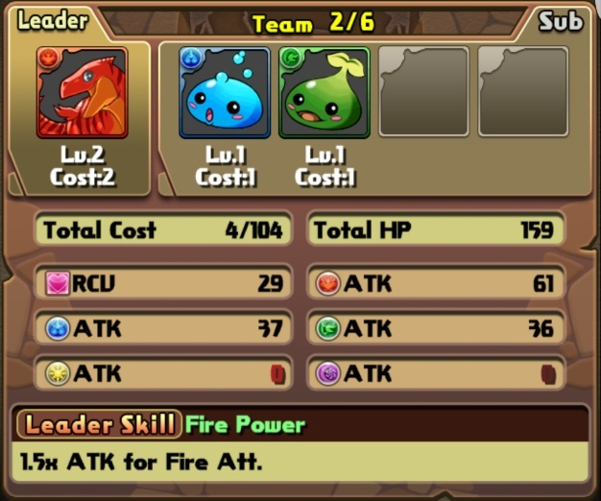Allow Updating of Base Monster Information as Game Updates
* Allow Viewing of Teams and Monsters of other Users, but that Information shall not be altered.
* The Database Shall have descriptions of Active, Leader, Awoken, and latent Skills.

## Usability Requirements

* Information retrieved shall be correct.
* Information shall not be altered by unauthorized users

## Performance Requirements

* 75% of Queries shall be processed in less than 5 second.
* 100 Transactions shall be supported at once.

## Logical Database Requirements

* Database Base Information Requires update as Game Updates
* Users shall be able to update Information pertaining to the user, their instanced Monsters, and their Teams.
* Monster Instances rely on Monster Base stats to calculate monster instance stats
* Users will be able to access information through an application designed specifically for use of the database, not an RDBMS
* Users will need to authenticate to grant access to modifying their information.

## Design Constraints

* Design Limited to Information retrieved from third party resources.

## Software System Attributes

* The Database Shall return information only Relevant to the playerID Used to Access the Database.
* The User Shall not be able to modify information outside of their playerID.
* Database information shall be available to users only through applications designed to access the database, not an RDBMS

## Standards compliance

* Table and Key Names Shall be CamelCase with a starting Capital Letter

## Supporting Information

### Game Mechanics

#### Player

The Account of the User Keeping all progress and consisting of:

* **Player ID –** A static 9 Digit identifier of the player account
* **Name –** A changeable String identifier of the player.
* **Rank –** A Number to Rank the amount of play players have played, Refills Stamina, and increase limits when obtained.
* **Max Stamina –** The Maximum Amount of Stamina obtainable, Increase’s with Rank
* **Stamina –** Regenerates 1 every 5 mins, fills on Rank up or with a magic stone.
* **Coins –** In Game Currency, Used in power-up fusion, and Dungeon Purchases.
* **Magic Stones –** In Game Currency Gained from first time Dungeon Completion, Real money purchase, promotional events. Used to pull Rare Egg Machine, Restore Stamina, fully heal team on lose.
* **Quests –** A set of Goals to complete which grant various Rewards, In the form of Dungeons, Badges, Monsters and Currency.
* **Monster** **Collection –** The Players collection of Monsters.
* **Experience –** The Amount of Experience the player has obtained.
* **Starting Attribute –** Depended on starting monster picked, Places icon next to name. No known effects, more information needed.
* **Teams –** Groups of 1-5 monsters picked by the player, used in dungeons.

Magic Stones

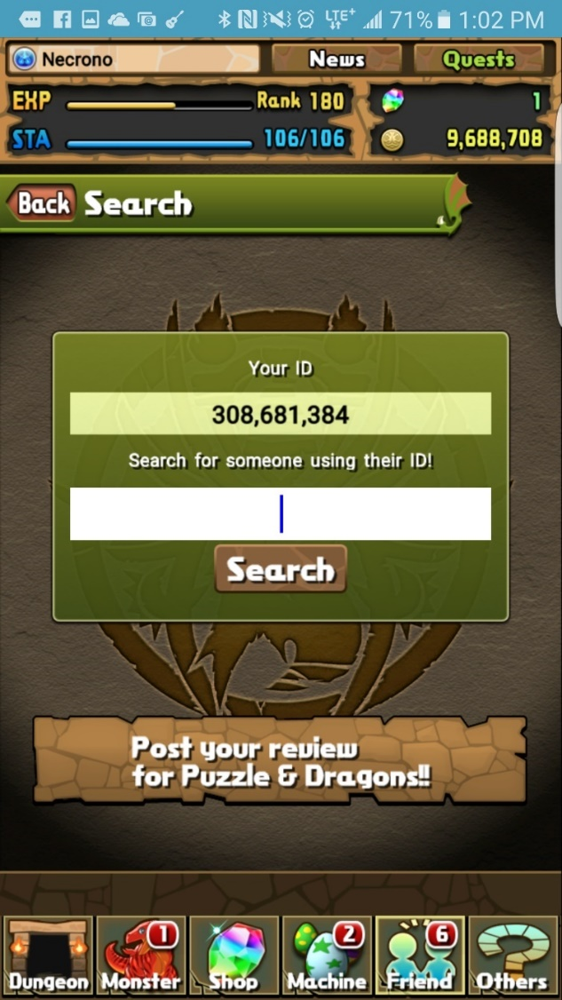

Player ID

Coins

Name and starting element.

Experience and stamina

#### Monsters

Each Monster Must Consists of:

* **ID Number –** An Integer Identifier.
* **Name –** A String Identifier
* **Rarity –** A measure of worth and difficulty to obtain.
* **Attributes (1 - 2)** – Specifies the type of damage dealt.
* **Monster Types –** The classification of a monster
* **Stats** for **HP** **ATK** and **RCV**
  + **HP**, **ATK**, and **RCV** are set for each monster, with a Min, Max and **Growth Rate**.
* **Current Level** and A **Max Level**
  + **Max Level** can vary, Currently no higher that 99.
* **Team Cost –** The Cost needed to be available to assign the monster to a team.
* **Current Experience** and **Max Experience**.
  + **Max Experience** is determined through **Max Level** and **Experience curve**
  + **Experience** is Earned through Power-Up Fusion

They May Also Contain an:

* **Active Skill**
  + Set for Monsters, there are Numerous skills in the game.
  + **Active skills** can be leveled, they all have a set max level, each level reducing cooldown.
* **Leader Skill**
  + **A Passive Skill,** Only active on Monsters in **Leader** or **Helper** positions.
* **Awoken Skills**
  + Monsters can have 0 – 9
  + Awoken with **Awakening Material** (**Tamadra**), or Power fusion with the **same** Monster.
* **Latent Awaking skills**.
  + Monsters can currently have up to 6 (5 + 1 with **latent Tamadra(Slot)**)
  + Skills Correspond to **Latent Tamadra** used.
* **Plus Stats**
  + Ranges from 0 – 99 for each **HP**, **ATK**, and **RCV**
  + Obtained from Power-up fusing with monster drops with **Plus Stats**
* **Evolution Tree**
  + Monsters may be able to Evolve to a Rarer monster type meeting evolution Requirements.

Also, another Monster can be assigned as an **Assist** Monster Granting varies Enhancements.

* A **Secondary Active Skill**, Possible Stat Improvements
* 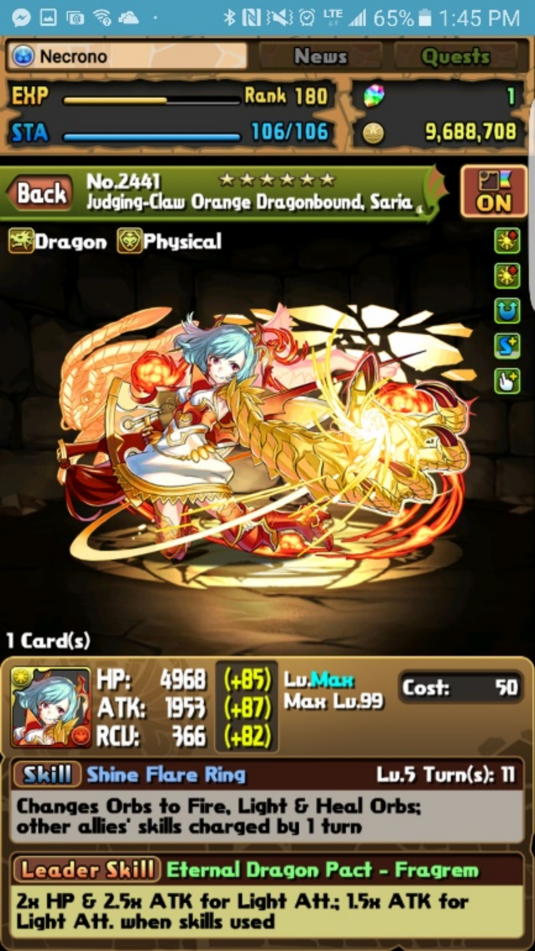

Stats

Types

Awoken Skills

Plus Stats

Current Level

Max Level

Team Cost

Secondary Attribute

Primary Attribute

Skill Level and Cooldown

Rarity

ID Number

Name

Number Owned

Leader Skill

Active Skill

#### Team Building

* Composition – **Leader** + 0 - 4 **Sub Monsters**
* **HP** – Sum of **HP** stat of all Monsters on Team
* **Team HP** – (Leader HP + Sub1 HP + Sub2 HP + Sub3 HP + Sub4 HP)
* **Team Cost** – The amount of team points to use the Team.
* **Team ATK** is broken up into each Attribute
  + The ATK of a specific Attribute is the sum of the ATK of each monster with that Attribute as their primary Attribute plus 1/3 of each monster ATK with that Attribute as their secondary and not their primary otherwise plus 1/10 of any monster ATK that has the Attribute as their dual Attribute
* Top of Form
* **Team RCV**- Sum of RCV stat of all Monsters on Team
  + Team RCV = Leader RCV + Sub1 RCV + Sub2 RCV + Sub3 RCV + Sub4 RCV
* **Badge** – Passive effect to entire team.

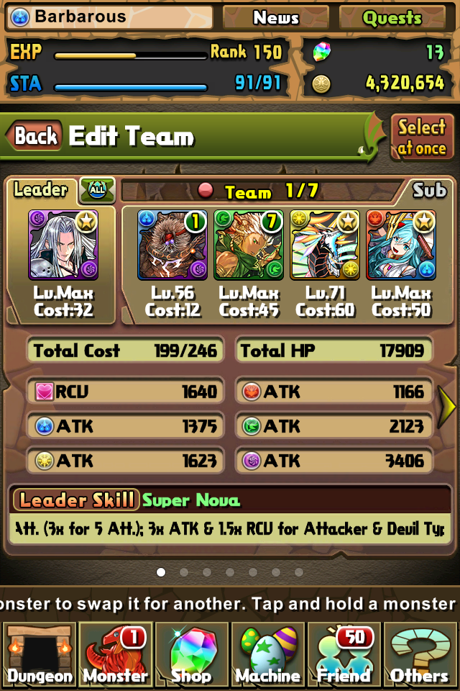

Team ATK

Team HP

Sub Monsters

Team Cost

Team RCV

Leader

Badge

Bottom of Form

# Verification

If Information within the database needs first party verification, we are limited to comparing within the application itself, if said Information is available i.e. Monster is owned.

# Appendices

## Assumptions and dependencies

Assumptions are the information retrieved from PuzzleDragonsX.com is current and correct.

## Acronyms and Abbreviations

* PAD – Puzzles and Dragons
* HP – Health Points
* ATK – Attack
* RCV – Recover
* RDBMS – Remote Database Management service